1. SOLUTION/NETWORK ARCHITECTURE
   1. **SOLUTION ARCHITECHTURE**

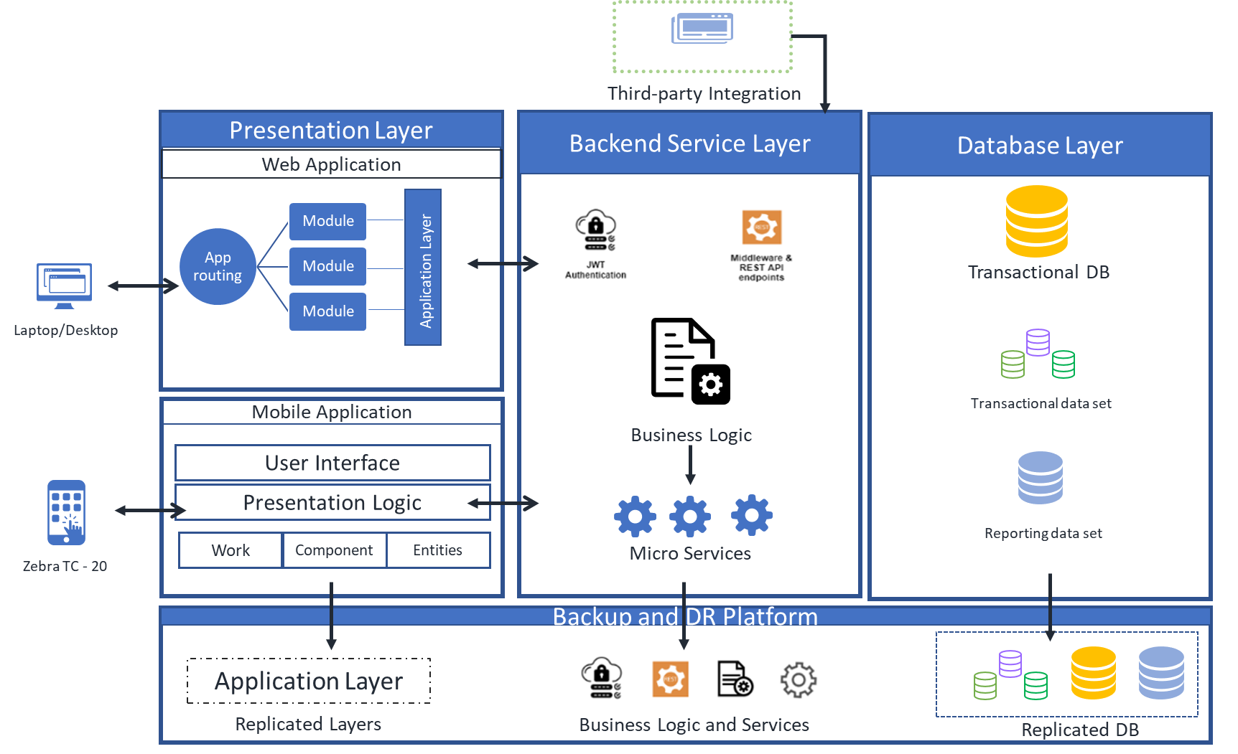

Figure: Solution Architecture

* 1. **TECHNOLOGY ENVIRONMENT**

Before deployment, System Administrator or respective concern needs to prepare the Servers as per Network Architecture. Below environments need to be created and installed to run the system.

|  |  |
| --- | --- |
| Particulars | Details |
| OS Platform | CentOS 8 |
| Database | MySQL (Latest Version) |
| Web Server | Apache |
| Front-End Language | React JS |
| Backend Language | Node JS |

**Note:**

Since we are in analysis stage, we will also explore some other Open-source platforms for this solution.

* 1. **NETWORK ARCHITECTURE**

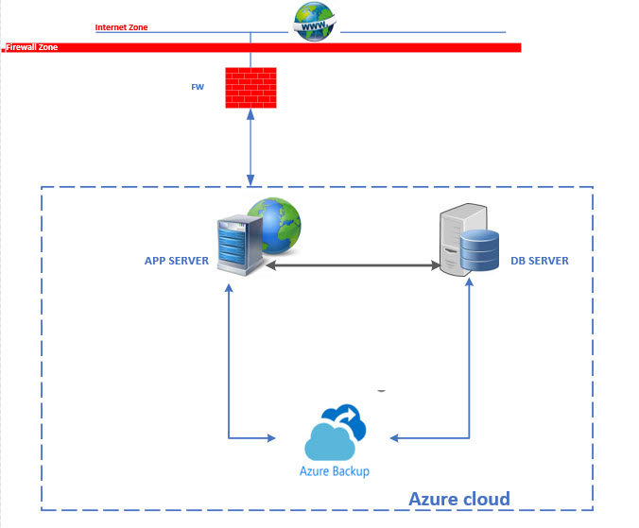

* 1. **SERVER SPECIFICATION**

Apsis is under the Microsoft Cloud Solutions Provider Program aka CSP. As a Cloud Solution Provider partner, we can create and deliver differentiated offers to customers, selling the Microsoft cloud portfolio and third-party solutions from the Microsoft commercial marketplace alongside their own value-added solutions and services. We are enabled to manage the entire customer engagement lifecycle and establish their credibility with customers as trusted advisors.

|  |  |  |  |
| --- | --- | --- | --- |
| **Microsoft Azure Estimate** | | |  |
| **Service type** | **Custom name** | **Region** | **Description** |
| Virtual Machines | APP | Southeast Asia | 1 D8s v4 (8 vCPUs, 32 GB RAM) (1 year reserved), Windows (AHB), OS Only; 1 managed disk – E10, 10,000 transaction units; Inter Region transfer type, 5 GB outbound data transfer from Southeast Asia to East Asia |
| Storage Accounts | DATA DISK | Southeast Asia | Managed Disks, Standard SSD, LRS Redundancy, E15 Disk Type 1 Disks; Pay as you go |
| Virtual Machines | DB | Southeast Asia | 1 E8s v4 (8 vCPUs, 64 GB RAM) (1 year reserved), Windows (AHB), OS Only; 1 managed disk – E10, 1,000 transaction units; Inter Region transfer type, 5 GB outbound data transfer from Southeast Asia to East Asia |
| Storage Accounts | DATA DISK | Southeast Asia | Managed Disks, Standard SSD, LRS Redundancy, E15 Disk Type 1 Disks; Pay as you go |
| Azure Backup |  | Eat Asia | Azure VMs, 2 Instance(s) x 500 GB, GRS Redundancy, Moderate Average Daily Churn, 30 GB Average monthly snapshot usage data |